ABSTRACT :

The Ultrasonic Liquid Monitoring System project focuses on designing, developing, and implementing a non-contact liquid level detection system using ultrasonic technology. This project is because there is an urgent need to accurately and reliably monitor liquid levels in industrial tanks and containers, which are often valuable, potentially hazardous, or corrosive liquids. The proposed system uses ultrasound pulses to measure the time it takes for the echo to return, providing accurate data about the depth of the empty space above the liquid.

The main objectives of this project include solving challenges such as preventing spills, improving safety, and increasing process efficiency. By mounting an ultrasonic detector on the top of the tank, this system ensures a non-invasive and adaptable solution for various industrial applications. Ultrasonic pulses propagate through air and the speed of sound at a certain temperature is taken into account for accurate calculations.

KEYWORDS:

Arduino UNO, Ultrasonic sensor, Pressure sensor, Esp8266 wifi module, IoT cloud Thingspeak

INTRODUCTION:

In today's industrial and residential environments, the accurate monitoring of liquid levels and water pressure is paramount for ensuring efficient operations and safety. Traditional methods often involve manual checks or outdated systems, leading to potential inaccuracies and inefficiencies. To address these challenges, this project focuses on developing an advanced liquid-level monitoring system that integrates Arduino UNO, an ultrasonic sensor, a pressure sensor, and the ESP8266 WiFi module. Through seamless connectivity and data transmission, this system enables real-time monitoring and visualization of liquid levels and water pressure, with data stored in the IoT cloud platform ThingSpeak. By eliminating the need for manual checks, this system provides users with convenient access to accurate data, enhancing operational efficiency and risk management.

The Arduino UNO serves as the central processing unit, facilitating communication between the sensors and the ESP8266 WiFi module. The ultrasonic sensor enables non-contact distance measurement, allowing precise monitoring of liquid levels, while the pressure sensor accurately assesses water pressure variations. The ESP8266 WiFi module enables wireless data transmission to the ThingSpeak IoT cloud platform, where the collected data is stored and visually presented in the form of graphs.

This project is driven by the imperative to enhance operational efficiency, safety, and resource optimization across various applications. By leveraging advanced sensor technologies and IoT connectivity, the system provides a comprehensive solution that eliminates the need for manual monitoring. Users can remotely access real-time data and visualizations, empowering them to make informed decisions and respond promptly to changes in liquid levels and water pressure.

The proposed liquid-level monitoring system offers a reliable, efficient, and user-friendly solution for industries, residential settings, and other applications. By seamlessly integrating Arduino UNO, ultrasonic and pressure sensors, the ESP8266 WiFi module, and the ThingSpeak IoT cloud platform, this system enables automated monitoring and visualization of liquid levels and water pressure, ensuring operational efficiency and safety without the need for manual intervention.

COMPONENTS:

1. Arduino UNO:

Arduino serves as an open-source platform employed for crafting electronic projects. It encompasses a physical programmable circuit board, often referred to as a microcontroller, along with an Integrated Development Environment (IDE) software, which runs on your computer to facilitate writing and uploading code onto the physical board. Unlike alternative systems, Arduino doesn't necessitate additional hardware for uploading new code onto the board; a simple USB cable is all that's required. Moreover, the Arduino IDE utilizes a simplified version of C++, thus streamlining the programming learning curve.

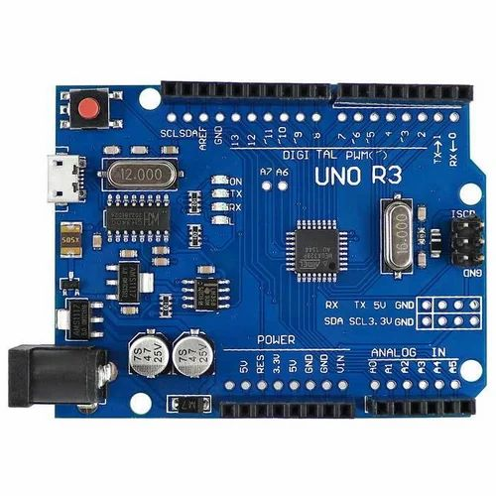

1. Ultrasonic Sensor:

The ultrasonic sensor, a non-contact device, is utilized for measuring an object's distance and velocity by leveraging sound wave properties. It operates by emitting sound waves at specific frequencies and detecting their rebounds to determine both the velocity and distance of the object.

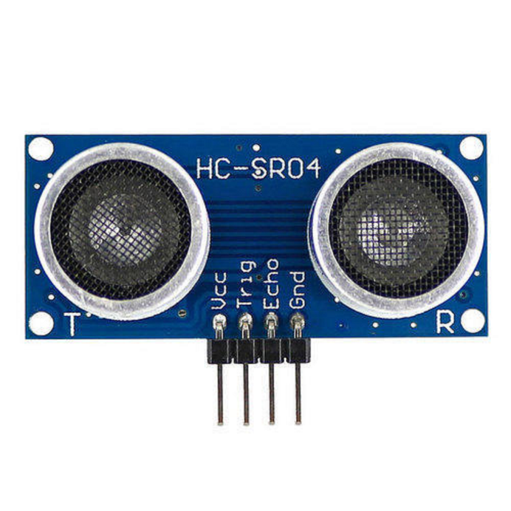

1. Pressure Sensor:

A pressure sensor is a device that measures pressure, which is the force exerted by a fluid on the sensor's surface. It converts this pressure into an electrical signal, which can then be interpreted by electronic devices. They play a crucial role in controlling and monitoring processes, ensuring safety, and optimizing performance.

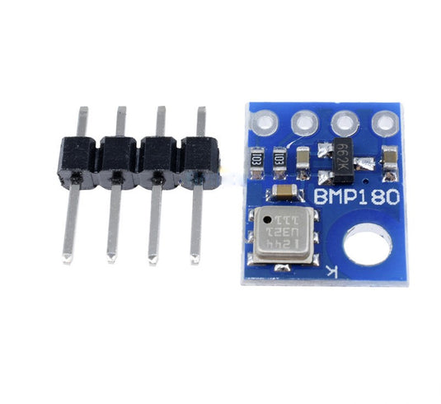

1. ESP8266 Wifi Module:

The ESP8266 is an affordable Wi-Fi microchip that includes integrated TCP/IP networking software. Functioning as a wireless network microcontroller module, it serves as a system-on-a-chip (SoC), offering features like 2.4 GHz Wi-Fi and general-purpose input/output capabilities.

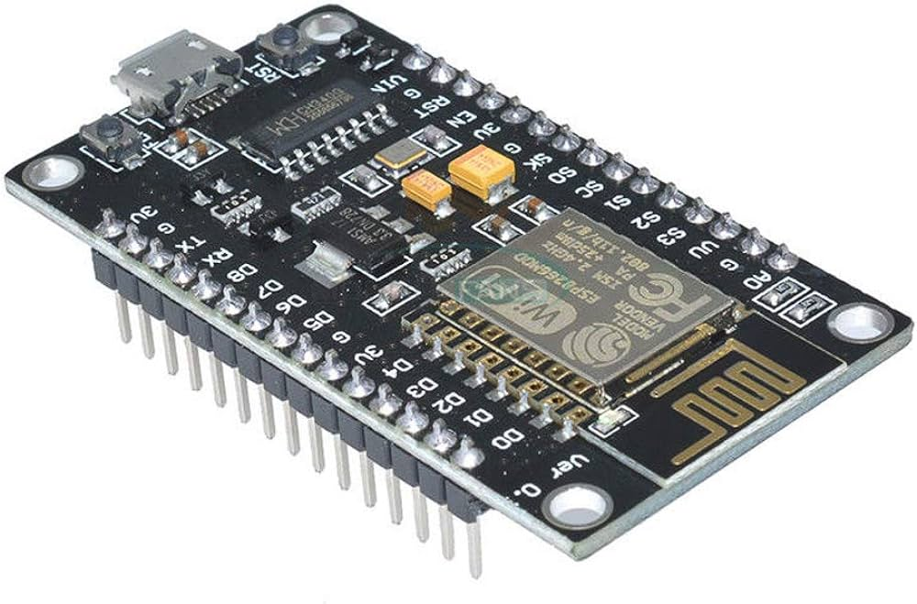

1. IoT Cloud called ThingSpeak:

ThingSpeak is an open IoT platform with MATLAB analytics. ThingSpeak allows you to aggregate, visualize, and analyze live data streams in the cloud. ThingSpeak provides instant visualizations of data posted by your devices or equipment.

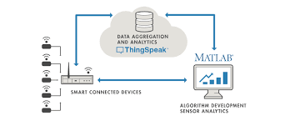

ARCHITECTURE:

The liquid level monitoring system's architecture is engineered to offer thorough and precise tracking of liquid levels and water pressure across a variety of industrial, commercial, and residential environments. The system is built around a suite of hardware and software components, carefully integrated to guarantee smooth functioning and dependable data transmission.

Starting with the hardware, the system employs the Arduino UNO microcontroller as its main processing unit. This adaptable microcontroller orchestrates the tasks of data gathering, processing, and transmission. Attached to the Arduino UNO are the ultrasonic sensor and the pressure sensor. The ultrasonic sensor is key in determining the distance to the liquid surface, thereby providing accurate data on the liquid level. Concurrently, the pressure sensor provides an accurate measure of the water pressure, supplying additional data vital for thorough monitoring.

Additionally, the architecture includes the ESP8266 Wi-Fi module, an affordable and effective solution for wireless communication. The ESP8266 module facilitates the smooth transfer of sensor data to the ThingSpeak IoT cloud platform. Using the Arduino IDE, the Arduino UNO is programmed to gather data from the sensors, process it, and send it to the ESP8266 module. Upon receipt, the ESP8266 module connects securely to the Wi-Fi network and forwards the data to the ThingSpeak cloud platform.

The ThingSpeak IoT cloud platform acts as the central storage and visualization hub for the collected data. By harnessing ThingSpeak's capabilities, users can gain real-time insights into variations in liquid level and water pressure via interactive graphs and charts. This visualization enables users to track the system's performance, spot trends, and make data-driven decisions to optimize operations and manage resources.

In conclusion, the liquid level monitoring system's architecture represents a comprehensive approach to tracking and managing liquid levels and water pressure. By flawlessly integrating hardware components like the Arduino UNO, ultrasonic sensor, pressure sensor, and ESP8266 Wi-Fi module with the ThingSpeak IoT cloud platform, the system offers a sturdy and adaptable solution for a range of applications. Through precise data collection, dependable transmission, and user-friendly visualization, the system enables users to boost operational efficiency, ensure safety, and make the most of resource utilization.

FUTURESCOPE:

The liquid level monitoring system, comprising Arduino, ultrasonic and pressure sensors, ESP8266 Wi-Fi module, and ThingSpeak IoT cloud platform, holds promising avenues for future advancements and applications. In the future:

* Enhanced sensor integration can provide comprehensive environmental monitoring capabilities.
* Advancements in data analytics and machine learning can enable predictive maintenance and process optimization.
* Remote control and automation features can be refined for seamless integration with smart home and industrial systems.
* Scalability and deployment in larger IoT networks offer centralized management across multiple locations.
* Adaptation for environmental monitoring and integration with smart agriculture systems can further broaden its utility and impact.

ADVANTAGES:

* Accurate measurement of liquid levels and water pressure
* Non-contact operation minimizes risk of contamination and damage
* Real-time monitoring enables prompt decision-making and response
* Cost-effective compared to traditional systems
* Easy installation with plug-and-play functionality
* Data visualization via ThingSpeak IoT cloud platform
* Versatile and adaptable to various environments and applications
* Remote accessibility enhances convenience for users

REFERENCES

1. Abadi, T. K. (2016). Design and implementation of liquid level monitoring system using capacitive sensor. International Journal of Engineering Trends and Technology (IJETT), 31(1), 28-33.
2. An, Y., Huang, Y., & Wang, S. (2019). Research on liquid level monitoring system based on Internet of Things. In 2019 IEEE 9th Annual International Conference on CYBER Technology in Automation, Control, and Intelligent Systems (CYBER) (pp. 49-52). IEEE.
3. Ayub, S., Bakar, A. A., Bakar, N. A., Khan, S., & Zafar, N. (2015). Development of liquid level monitoring system for oil and gas industry using pressure sensor.

ARPN Journal of Engineering and Applied Sciences, 10(23), 17645-17651.

1. Chien, M. H., & Chen, Y. W. (2019). Development of a capacitive liquid level monitoring system. Sensors, 19(2), 267.
2. Chong, P. H. J., & Ismail, F. S. (2017). Ultrasonic liquid level monitoring system. In 2017 IEEE Conference on Systems, Process and Control (ICSPC) (pp. 131-135). IEEE.
3. Deng, H., & Shang, Y. (2018). Ultrasonic liquid level monitoring system design based on STM32. In 2018 2nd International Conference on Circuits, System and Simulation (ICCSS) (pp. 121-124). IEEE.
4. Fang, Y., Wang, H., & Cao, J. (2016). Design of intelligent liquid level monitoring system based on IoT. International Journal of Smart Home, 10(7), 17-24.
5. Gao, Y., Tan, Z., & Chen, L. (2020). Design of water tank liquid level monitoring system based on wireless communication technology. International Journal of Distributed Sensor Networks, 16(1), 1550147719899032.
6. He, H., Han, D., Han, S., & Li, L. (2021). Research and implementation of liquid level monitoring system based on Internet of Things. In 2021 IEEE 3rd Information Technology and Mechatronics Engineering Conference (ITOEC) (pp. 676-680). IEEE.
7. Khongkum, S., & Wongratanaphisan, T. (2018). An ultrasonic liquid level monitoring system for automotive urea tank. International Journal of Smart Home, 12(6), 143-150.
8. Kuan, K. K., Zulhani, R., Husain, A. R., Ahmad, A. N., & Nasaruddin, F. H. (2016). Microcontroller based liquid level monitoring system using ultrasonic sensor. Journal of Telecommunication, Electronic and Computer Engineering (JTEC), 8(8), 147-150.
9. Liu, C., & Shen, M. (2021). Research on the liquid level monitoring system based on LoRa. In 2021 IEEE 6th International Conference on Cloud Computing and Big Data Analytics (ICCCBDA) (pp. 69-72). IEEE.
10. Majeed, H. A., & Tariq, S. A. (2018). An ultrasonic sensor-based water level monitoring system for agricultural purpose. International Journal of Scientific & Engineering Research, 9(11), 189-193.
11. Reddy, K. P., & Rangaswamy, T. (2017). Design and implementation of IoT based liquid level monitoring system. International Journal of Engineering Research and Applications (IJERA), 7(6), 05-09.
12. Zhang, Y., Zhao, H., Zhang, X., Liu, Q., & Zhu, L. (2020). Liquid level monitoring system based on capacitive sensor and wireless communication. Journal of Physics: Conference Series, 1595(1), 012081.